Pinxton 0-5 Nursery School
(Toddler Room)
Week commencing the 30th May
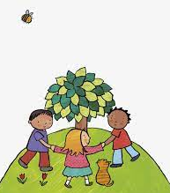
Our focus topic for the next fortnight is going to be ‘Health and Self-care’ and our song will be ‘Here we go round the mulberry bush’.

Our children will be read a range of different books and activities supporting the children with their knowledge on health and self-care. On Monday the children will be read ‘Monkey Business’ and then be encouraged to wash their hands to be awarded a handwashing certificate. Tuesdays story will be ‘ Freddie visits the dentist’ and after the children will be encouraged to talk about teeth brushing and then have a go with the big teeth with have available in nursery. On Wednesday the children will be read ‘First time doctor’ before talking about experiences with visiting the doctor and explore the babies with the doctor’s equipment to support the children’s imagination. Thursday the children will talk about health eating and be encouraged to try a range of different fruits which are involved in the story they will be read ‘Handa’s Surprise’. On Friday the children will be read ‘Little Owls Orange Scarf’ and explore a range of different types of clothing.
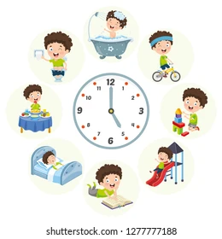
Supporting at home:
- Encourage your children to choose healthy foods in the shop when shopping
- Talk about why we need to look after ourselves, i.e. teeth brushes, hand washing, etc./
- Sing our focus song.

Key Words:
- Clean
- Hands
- Wash
- Soap
- Water
- Teeth
- Dentist
- Doctor
- Poorly
- Pain
- Medicine
- Tasty
- Heathy
- Coat
- Hat

Pinxton 0-5 Nursery School
(Baby Room)
Week commencing the 30th May
Our focus topic for the next fortnight is going to be ‘Health and Self-care’ and our song will be ‘Here we go round the mulberry bush’.
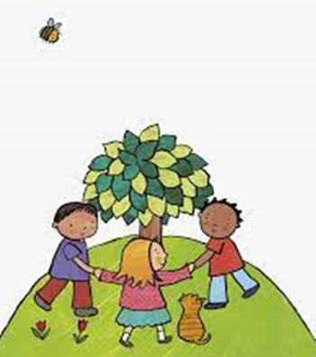
In the baby room for this topic we will be taking part in different creative activities each day, on Monday we will be making a collage using different red materials with glitter. On Tuesday the babies will be painting with stacking cups and getting messy in bright paint. Wednesday will be very messy with hand and feet printing. On Thursday we will make a yellow collage and explore the colour and the feel of the materials. And on Friday we will look at the different coloured bingo dobbers on a round paper plate.

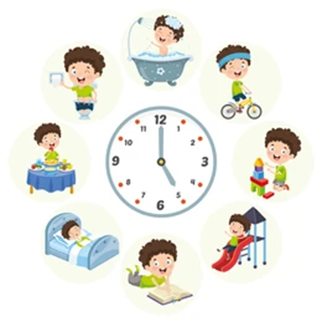
In our investigation we will be getting messy in flour and JCB diggers, splashing in bubble bath with babies and equipment, exploring a range of fruit with different textures and smells, brushing the teeth we have in nursery with toothpaste and bushes and exploring in rainbow shaving foam.

Our stories for the next fortnight will be ‘I don’t want to go to bed’, ‘What a busy Baby!’, ‘Baby noises’, ‘Hats’ and ‘Where’s Spot?’, these will be read each day before singing our focus song and other nursery rhymes.

