Pinxton 0-5 Nursery School
Week commencing 5 September 2022
Baby Room
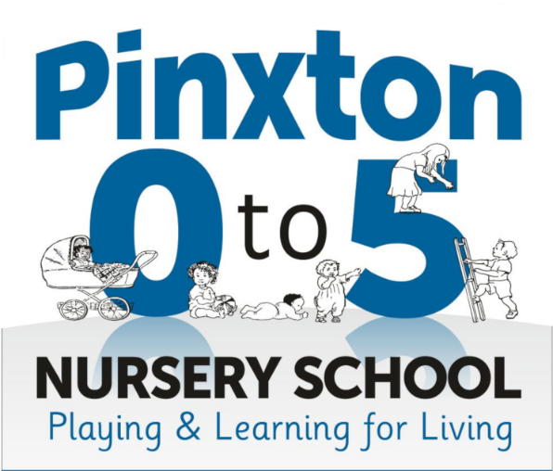
Our next fortnight topic in nursery is going to be ‘Our Nursery’ and our song is ‘Tommy Thumb’.

Over the next fortnight, the children will be read a range of different stories linking to our topic. These will be, ‘Where’s Spot?’, ‘Peekaboo House’, ‘Peekaboo in the jungle’, ‘Peekaboo Love’ and ‘Pop-up Bedtime’.

Each day the children will take part in a creative and investigation activity. For creative we will be fruit and vegetable printing, car track printing, animal border paper colouring with crayons or pencils, tissue paper collage with pva glue and hand printing with paint. In investigation, we will be washing babies in water and bubble, exploring in cereal and animals, cars and shaving foam, chopping up fruit and vegetables and mark making in cornflour with different tools.

Supporting at home:
- Sing our focus song
- Talk about nursery and what fun things your children will be doing when they are here
- Speak about the other children in nursery and who they’ve played with.
Tommy Thumb Lyrics
Tommy Thumb,
Tommy Thumb,
Where are you?
Here I am,
Here I am,
How do you do? (or How are you?)
Peter Pointer,
Peter Pointer,
Where are you?
Here I am,
Here I am,
How do you do? (or How are you?)
Toby Tall,
Toby Tall,
Where are you?
Here I am,
Here I am,
How do you do? (or How are you?)
Ruby Ring,
Ruby Ring,
Where are you?
Here I am,
Here I am,
How do you do? (or How are you?)
Baby Small,
Baby Small,
Where are you?
Here I am,
Here I am,
How do you do? (or How are you?)

