Pinxton 0-5 Nursery School
Week commencing 5 September 2022
Toddler Room
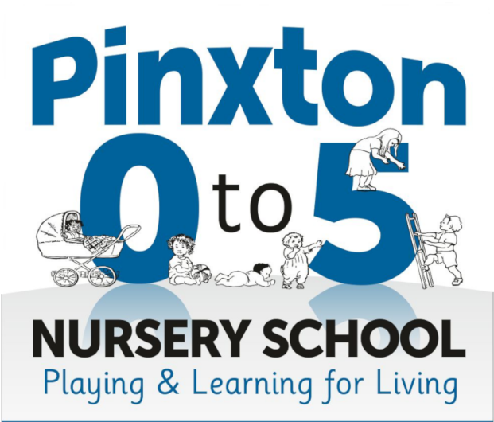
Our next fortnight topic in nursery is going to be ‘Our Nursery’ and our song is ‘Tommy Thumb’.


Over the next fortnight, we will be reading a range of books with the children, taking part in-group activities and then sing our focus song. On Monday, the children will be read ‘I can share’ and then the children will sit in a circle with an adult and roll a ball back and forth to each other to encourage sharing. Tuesday, the children will be read the book ‘the same but different too’ and then explore different sized animals and talk about them. On Wednesday, the children will be read ‘Our class is a family’ and then talk about familiar people within nursery and what they have available to play with each day. On Thursday, we will read ‘Dear Teacher’ and then talk about all the exciting things the children have done over the summer holidays. On Friday, our focus book will be ‘All are welcome’ and then explore a range of family photos alongside each other
Supporting at home:
- Sing our focus song
- Talk about nursery and what fun things your children will be doing when they are here
- Speak about the other children in nursery and who they’ve played with.
Keywords
- Welcome
- Family
- Friends
- Nursery
- Teacher
- Exciting
- Holidays
- Class
- Play
10. Kind

